**Laporan 8 – Hasil Prediksi M1 dan M4**

**M1 – Implementasi SB-LSTM-RNN tanpa iklim dan ENSO**

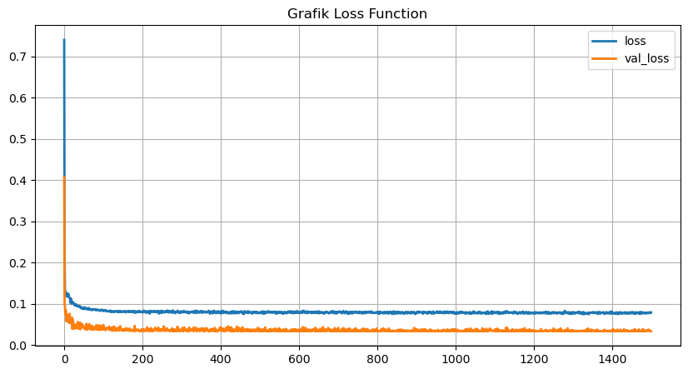

Gambar 1. Grafik loss function M1

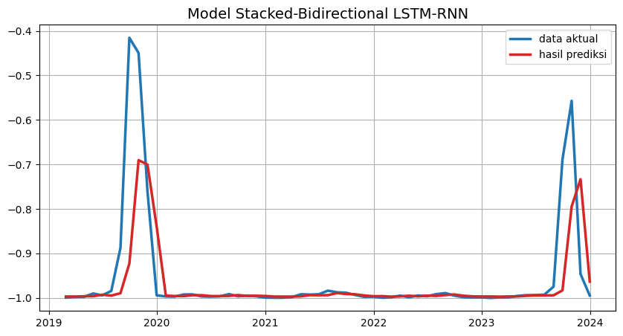

Gambar 2. Hasil prediksi titik panas M1

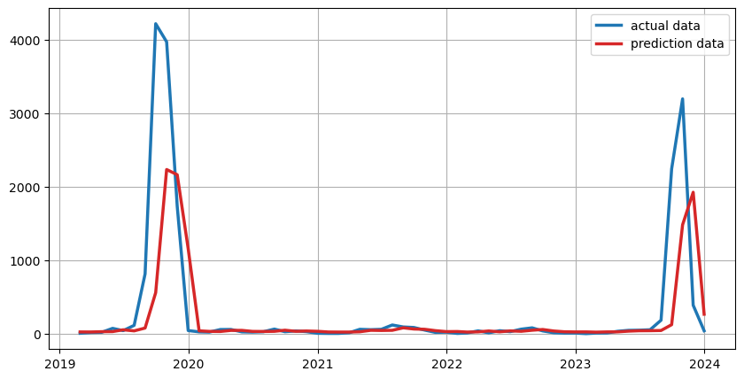

Gambar 3. Hasil prediksi titik panas M1

**M4 – Implementasi SB-GRU-RNN tanpa iklim dan ENSO**

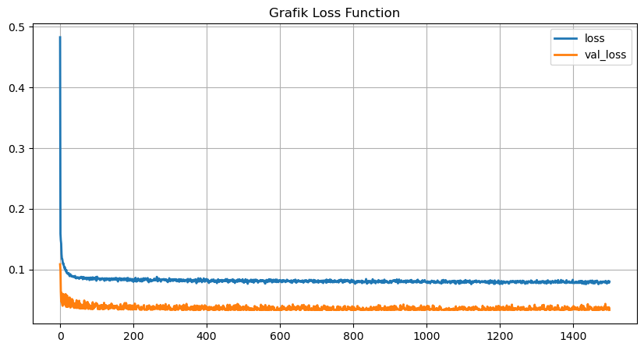

Gambar 4. Grafik loss function M4

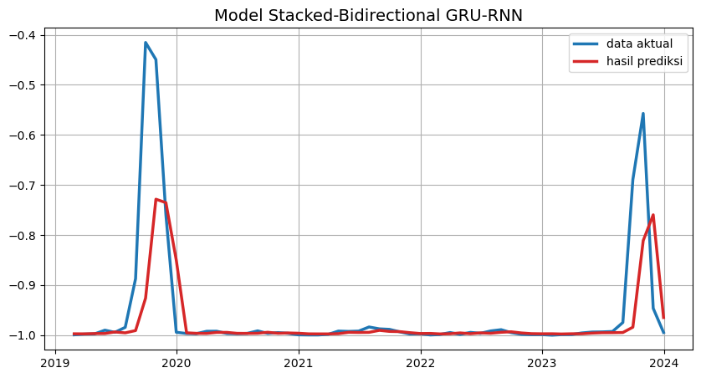

Gambar 5. Hasil prediksi titik panas M4

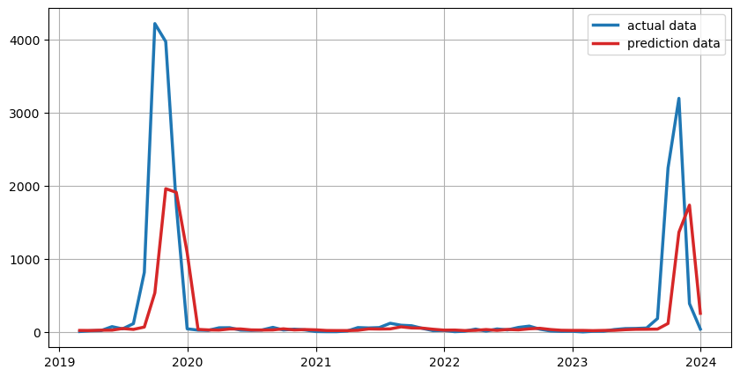

Gambar 6. Hasil prediksi titik panas M4

**Evaluasi Model Prediksi**

|  |  |  |  |  |
| --- | --- | --- | --- | --- |
| Model | Paramater Tuning NN | | | |
| Activation Function | Optimizers | Dropout | Batch Size |
| M1 | SeLU | SGD | 0,15 | 8 |
| M4 | SeLU | SGD | 0,25 | 4 |

|  |  |  |  |  |  |  |
| --- | --- | --- | --- | --- | --- | --- |
| Model | Parameter Eror | | | | | |
| MAE | MSE | MAPE | R | R2 | P-value |
| M1 | 3,373 | 0,921 | 5,71 | 0,648 | 0,419 | 0 |
| M4 | 3,346 | 0,947 | 5,77 | 0,65 | 0,422 | 0 |